


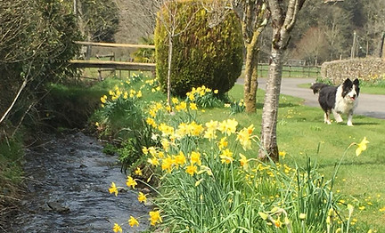

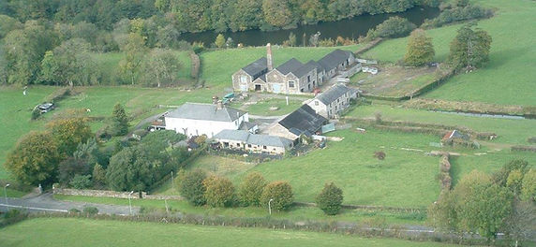
Dear Parents,
Class 4 Residential Trip 31st March - 3rd April 2025
Stone Farm Study Centre, Okehampton
I am delighted to let you know about our Residential Trip for 2025. We are visiting Stone Farm Study Centre in Okehampton, Devon. The dates are noted above. Detailed below is some provisional information about the trip, further details will be circulated at a later date.
Stone Farm Study Centre is located on the edge of Dartmoor in the heart of the Devon countryside. Set in the foothills of the National Park, the site boasts 110 acres of organic parkland pasture and is an idyllic retreat for children to visit.
First established in 1992 by two former teachers, Stone Farm Study Centre has welcomed schools for 30 years and they understand the educational, physical and emotional benefits school visits offer.

KEY FEATURES:
- A magnificent setting! They are situated in the foothills of Dartmoor on the edge of the National Park.
- EXPERIENCE: Stone Farm has welcomed over 30,000 children since they were established in 1992!
- Wholesome farmhouse food - cooked breakfasts, packed lunches and home-cooked evening meals (4/5 choices per evening!) are all prepared in their farmhouse kitchen and included in their price.
- On-site facilities include campfire circle, fully equipped games room, bale-maze, animal sketching, barn dance/disco area and barn cinema.

The cost for each child for the Residential Centre is £322.97. This sum includes accommodation on a full board basis whilst at the study centre and the cost of all the planned activities. This also includes the costs of the coach hire and costs of transport whilst we are away. To mitigate the impact to parents the PTA have kindly agreed to contribute £600 to the cost of the coach. We appreciate that these are difficult times with financial constraints placed upon many of us and the implications it may cause and so to aid parents spread the cost of the residential trip across the year we will set up a prepayment scheme via School Money. The first payment/deposit of £20 is due by the 30th September 2024. It is requested that the full amount for the trip is paid no later than the 1st May 2025. If you envisage experiencing any difficulty in meeting this payment deadline, please liaise with me to discuss an alternative payment timescale. This cost includes activities which have not been finalised yet. If they change, costs may be reduced.
I have arranged a briefing to go through the specific details of the trip/timings etc after school in Class 4 on Monday 27th January 2025 at 3.30pm.
Please discuss any aspect of the trip with me if you have any concerns or queries about your child attending. We are aware of the financial demands placed on many of you at present and are here to help. We can access support organisations which we may be able to offer financial support to help families. Please speak with me about this if you require more information.

Can I ask therefore that you complete and sign the permission slip below by Friday 27th September 2024 to confirm your support for this booking.

Many Thanks,

Sarah Reynolds
Head Teacher
https://www.stonefarmstudycentre.co.uk/

To Shenington Cof E Primary School

I wish to reserve a place for my child ………………………………………… on the Residential Trip to Stone Farm Study Centre on 31st March – 3rd April 2025. I will ensure the initial deposit £20 is paid by the 30th September 2024 and the full cost of the trip is paid for by the 1st May 2025.

Signed …………………………………………. Date……………………

